**AWS -EC2**

**Elastic Compute Cloud**

**Dashboard:**

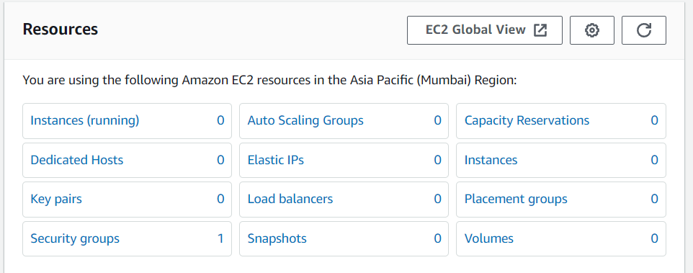

**Snapshots:**

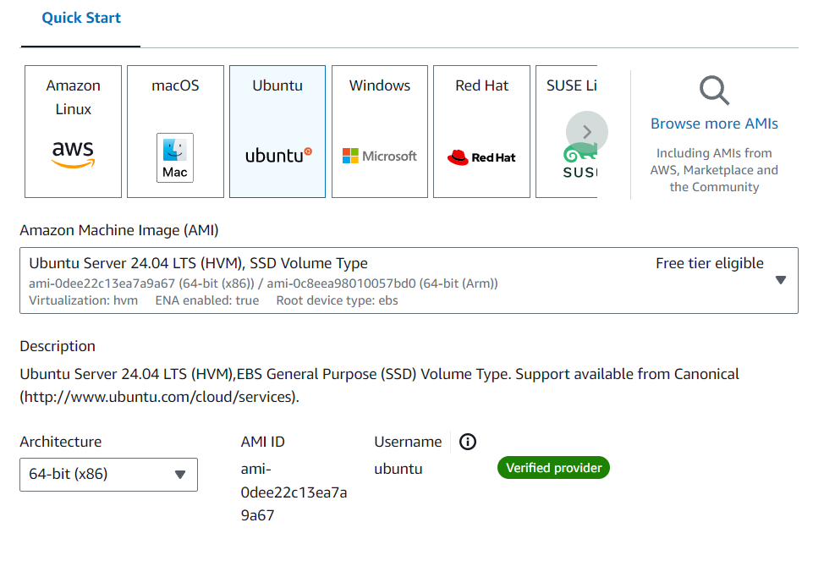

**Create a Key-Pair 👍**

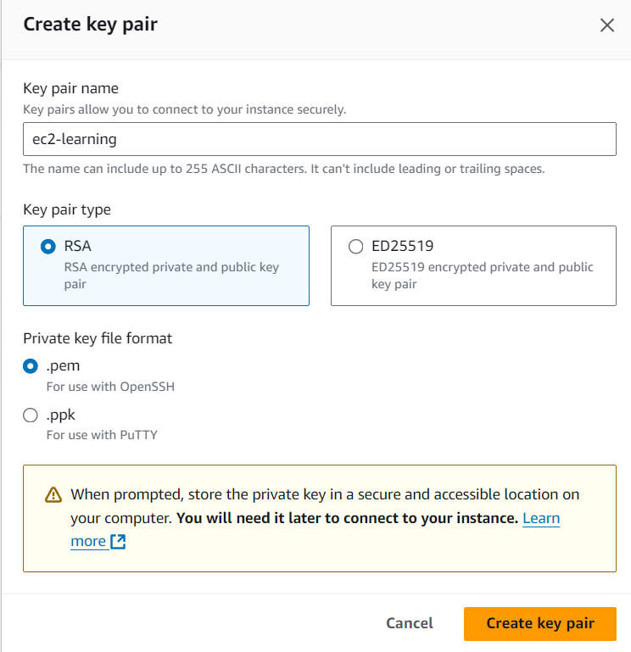

**An IPv4 address is a 32-bit number that uniquely identifies a network interface on a machine.**

**IPv4 addresses are made up of two parts:**

**Network prefix: Specifies the unique number assigned to a network**

**Host number: Uniquely identifies a host within a network**

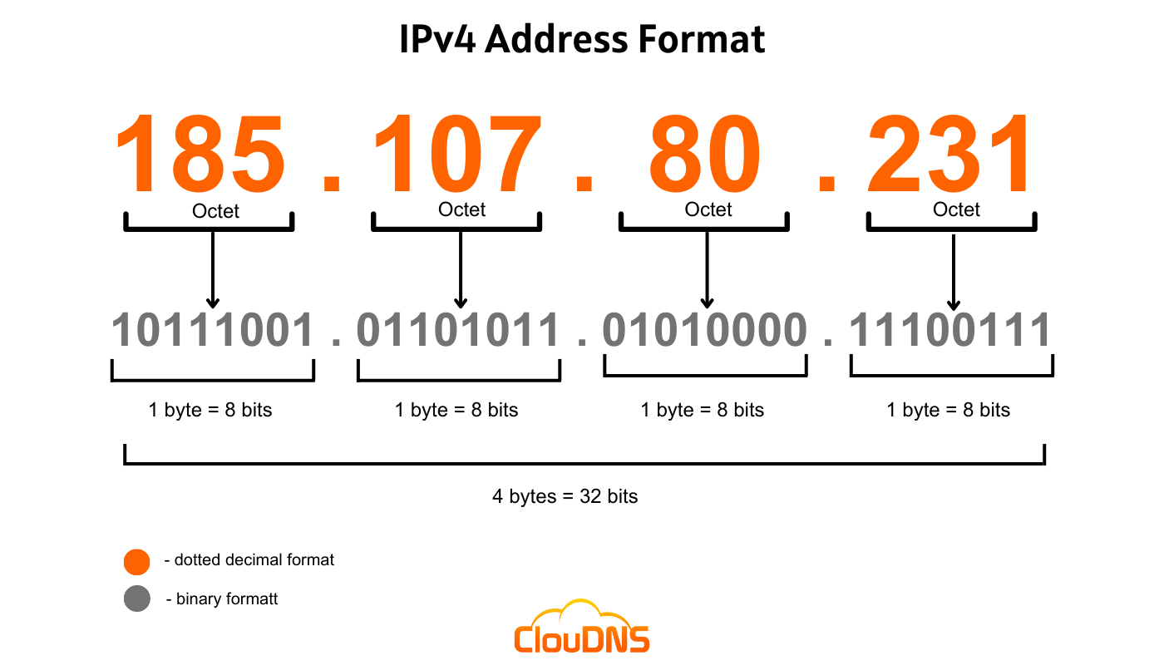

**An IPv6 address is a 128-bit alphanumeric value that identifies a device in an Internet Protocol Version 6 (IPv6) network. IPv6 is an advanced networking standard that allows for a much larger number of unique IP addresses than the older IPv4 standard.**

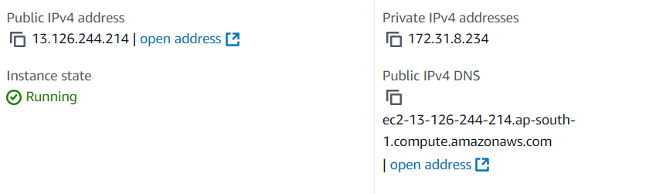

Difference between Public and Private IPv4 address:

Public IPv4 addresses are routable on the internet and assigned by IANA, allowing direct access from any device online.

Private IPv4 addresses are used within local networks and are not routable on the internet, falling within specific ranges (e.g., 192.168.x.x).

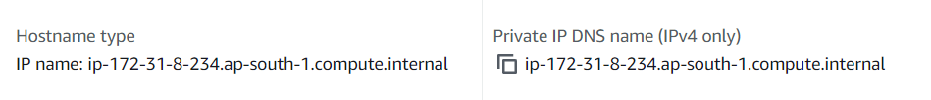

* Public Hostname: Accessible from the internet (e.g., ec2-203-0-113-25.compute-1.amazonaws.com).
* Private Hostname: Accessible only within the VPC (e.g., ip-10-0-1-23.ec2.internal).
* Private IP DNS Name: Resolves to the private IP (e.g., ip-10-0-1-23.ec2.internal).

What’s VPC?

A VPC (Virtual Private Cloud) is a virtual network dedicated to your AWS account. It allows you to launch AWS resources in a logically isolated environment.

You can define your own network configuration, including IP address ranges, subnets, route tables, and network gateways.

AMI:

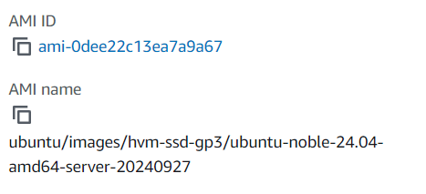

An AMI (Amazon Machine Image) is a pre-configured template used to create virtual machines (EC2 instances) on AWS. It contains the operating system, application server, and applications required to launch an instance.

Connection:

Command:

ssh -i /path/to/your-key.pem ec2-user@your-ec2-public-dns

- @your-ec2-public-dns: The public DNS or IP address of your EC2 instance.

Changing Permissions:

chmod 400 /path/to/ec2-learning.pem

On Windows:

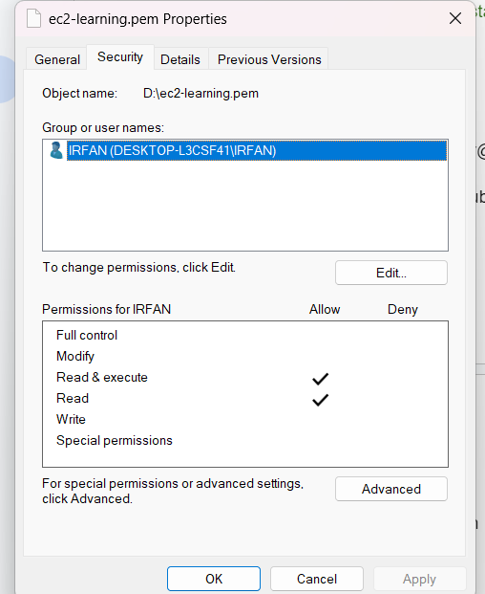

Some Commands:

* cat /etc/os-release

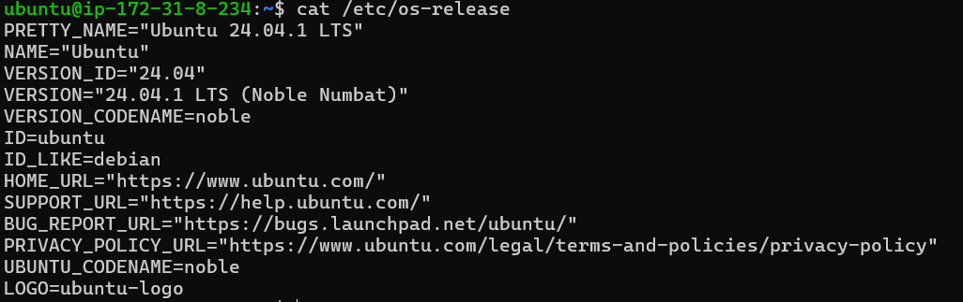

Know CPU Details:

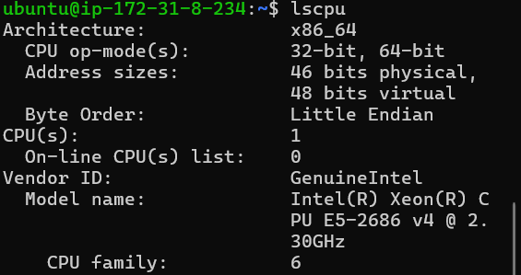

The command df -h is used in Unix/Linux systems to display information about disk space usage in a human-readable format.

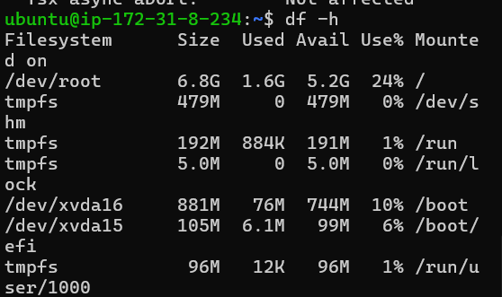

**INSTALLING NGINX** ⚒️

1. sudo -i : it opens a new shell with root user privileges, providing a login environment as the root user.
2. apt-get update : refreshes the package list for upgrades on Debian-based systems.
3. apt-get install nginx : installs the Nginx web server on Debian-based systems.
4. service nginx status : checks the current status of the Nginx service, indicating whether it is running, stopped, or inactive. 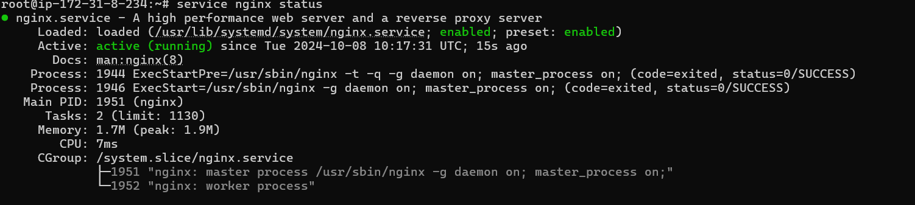
5. curl localhost : sends an HTTP request to the local server (localhost) and displays the response, typically the content served by a web server running on the same machine. 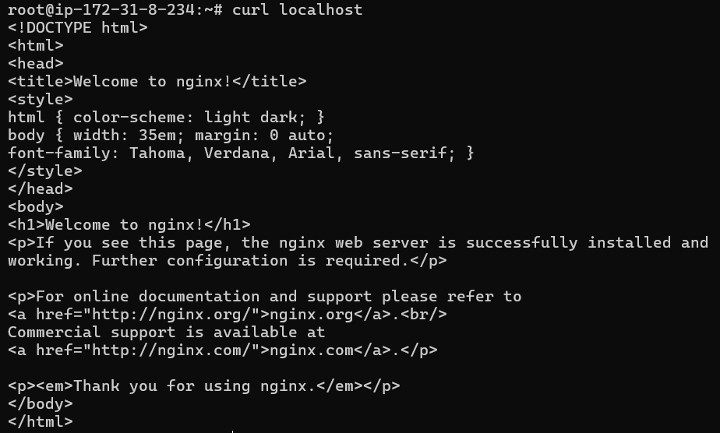

**AWS Security Groups act as virtual firewalls for your EC2 instances to control inbound and outbound traffic**.

Here’s a brief overview:

Key Features:

Stateful: If you allow an incoming request from an IP, the response is automatically allowed, regardless of outbound rules.

Rules: You define rules based on:

Protocol: TCP, UDP, ICMP, etc.

Port Range: Specific ports or ranges (e.g., 22 for SSH, 80 for HTTP).

Source/Destination: IP addresses or CIDR blocks (e.g., 0.0.0.0/0 for all IPs).

Default Security Group: Each VPC has a default security group that allows all outbound traffic and no inbound traffic.

Multiple Security Groups: You can assign multiple security groups to an instance, and the rules are aggregated.

Use Cases:

Allowing SSH access from specific IPs.

Restricting web traffic to certain ports.

Managing access for different application tiers (web, app, database).

Management:

Security groups can be modified at any time, and changes take effect immediately.

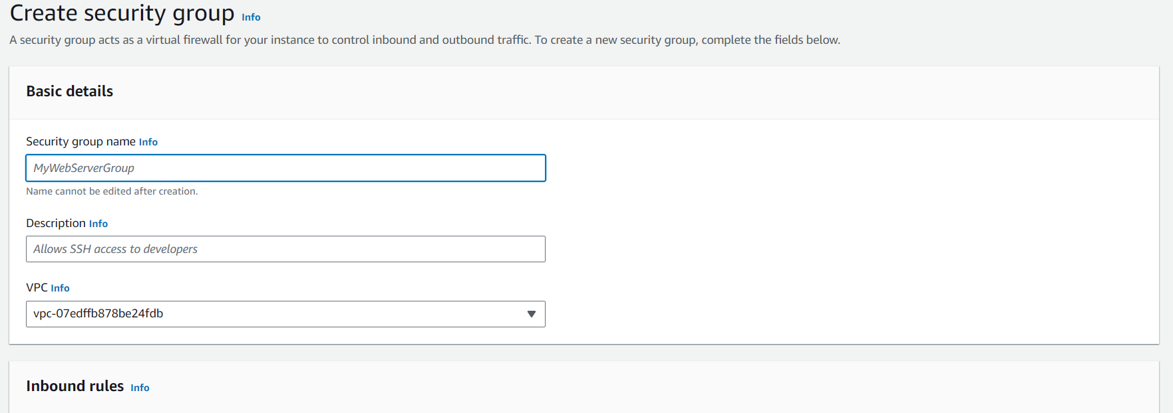

The main difference between the HTTP and HTTPS port numbers is that HTTP uses port 80, while HTTPS uses port 443:

Port 22 is used for Secure Shell (SSH) communication,

PLANS:

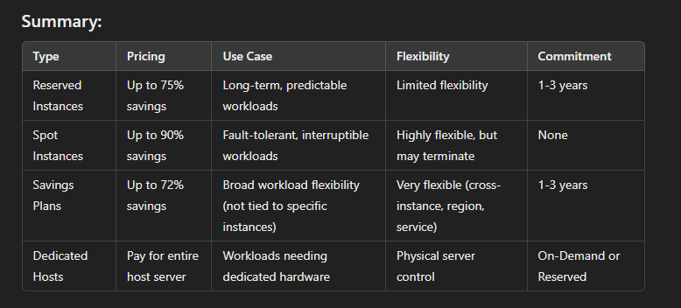

# **Instance Metadata With UserData**

curl 169.254.169.254 is used to make an HTTP request to the IP address 169.254.169.254, which is commonly associated with the AWS Instance Metadata Service

Here are the five most important curl commands to retrieve metadata from the AWS EC2 Instance Metadata Service:

Get Instance ID:

Copy

curl http://169.254.169.254/latest/meta-data/instance-id

Get Instance Type:

Copy

curl http://169.254.169.254/latest/meta-data/instance-type

Get Public IP Address:

Copy

curl http://169.254.169.254/latest/meta-data/public-ipv4

Get Private IP Address:

Copy

curl http://169.254.169.254/latest/meta-data/local-ipv4

Get AMI ID:

Copy

curl http://169.254.169.254/latest/meta-data/ami-id

These commands will give you essential information about your EC2 instance.

# **Attach Elastic/Static IP to an EC2 Instance:**

Click the Elastic IPs link in the EC2 Dashboard.

Click Allocate New Address and choose VPC or EC2 from the drop-down list, depending whether you're going to associate this IP with an instance in Amazon EC2-Virtual Private Cloud (VPC) or Amazon EC2-Classic, respectively.

Click Yes, Allocate to confirm your choice.